Technical Document Twitter Scraping with R and Python

This document provides information about the setup of a twitter scraper in R and Python.

Twitter Setup:

Go to: <https://developer.twitter.com/> and setup an account

Create an app:

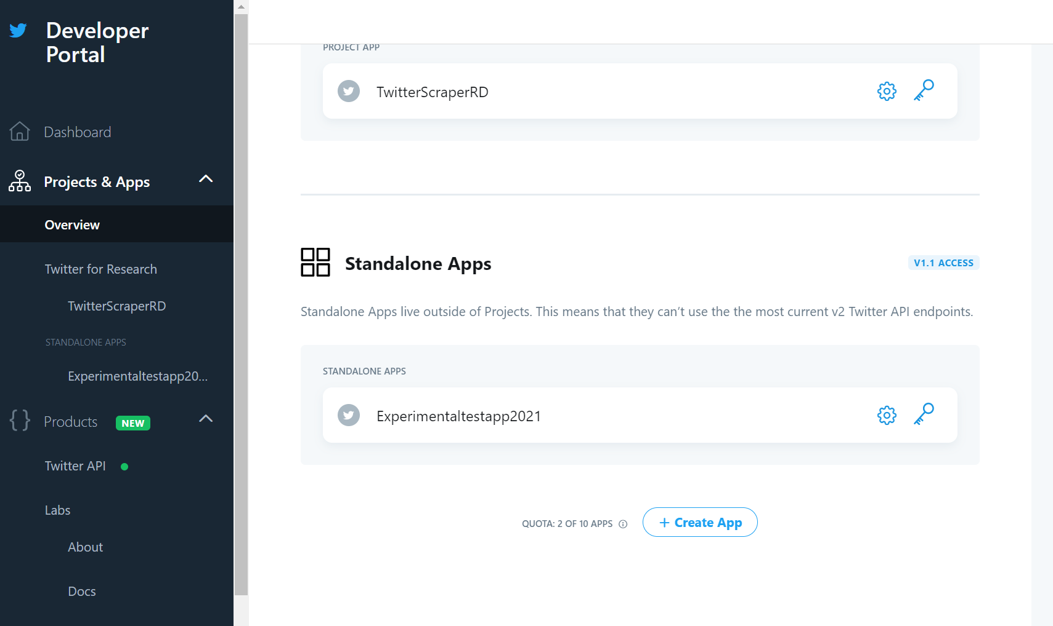

v

Generate Consumer and Authentication Token:

NOTE: YOU WILL HAVE TO SAVE THE KEYS TO A TEXT/DOC FILE, YOU WILL NEED THEM IN R/PYTHON

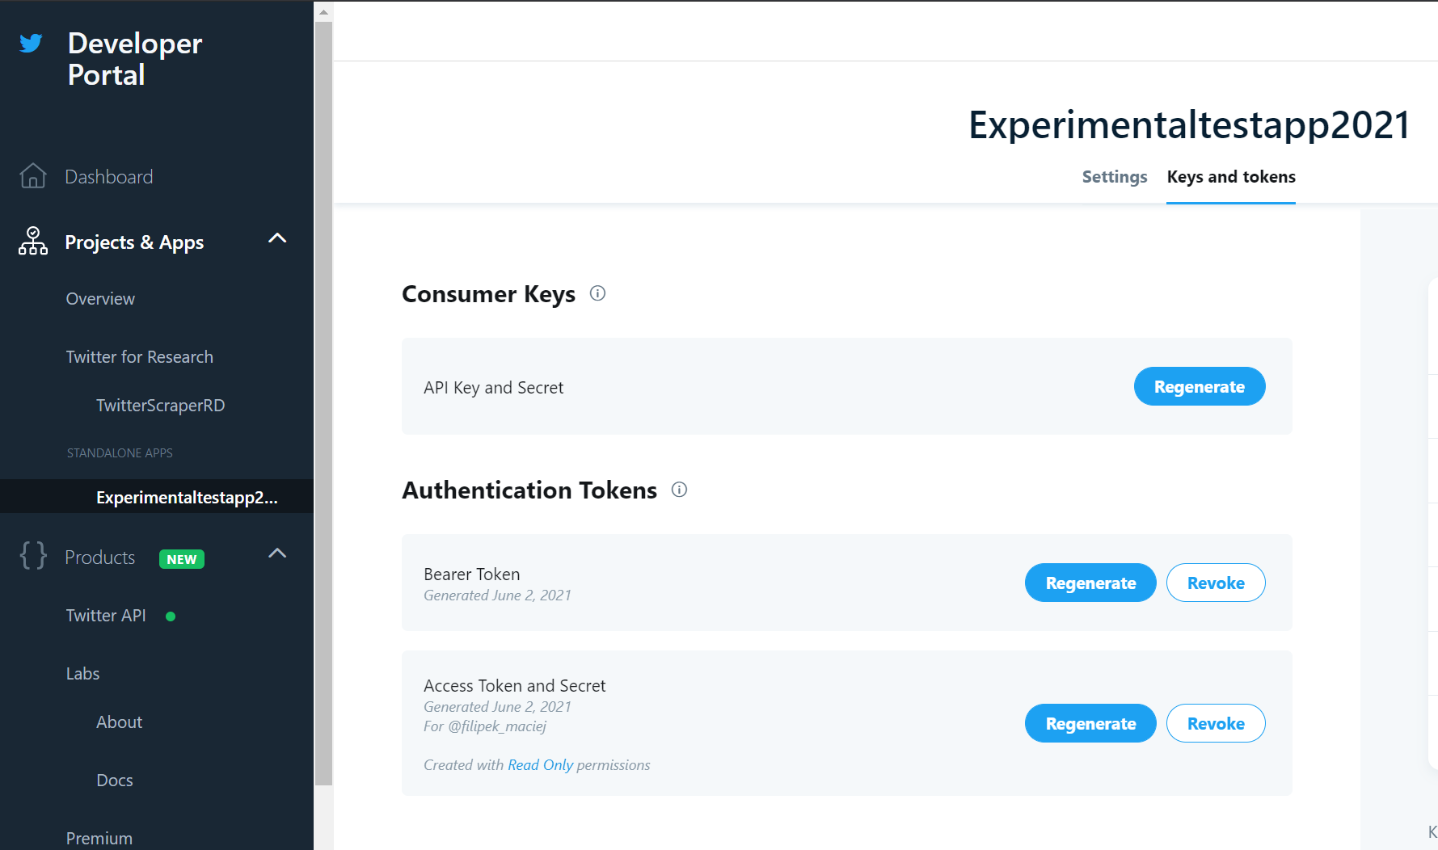

v

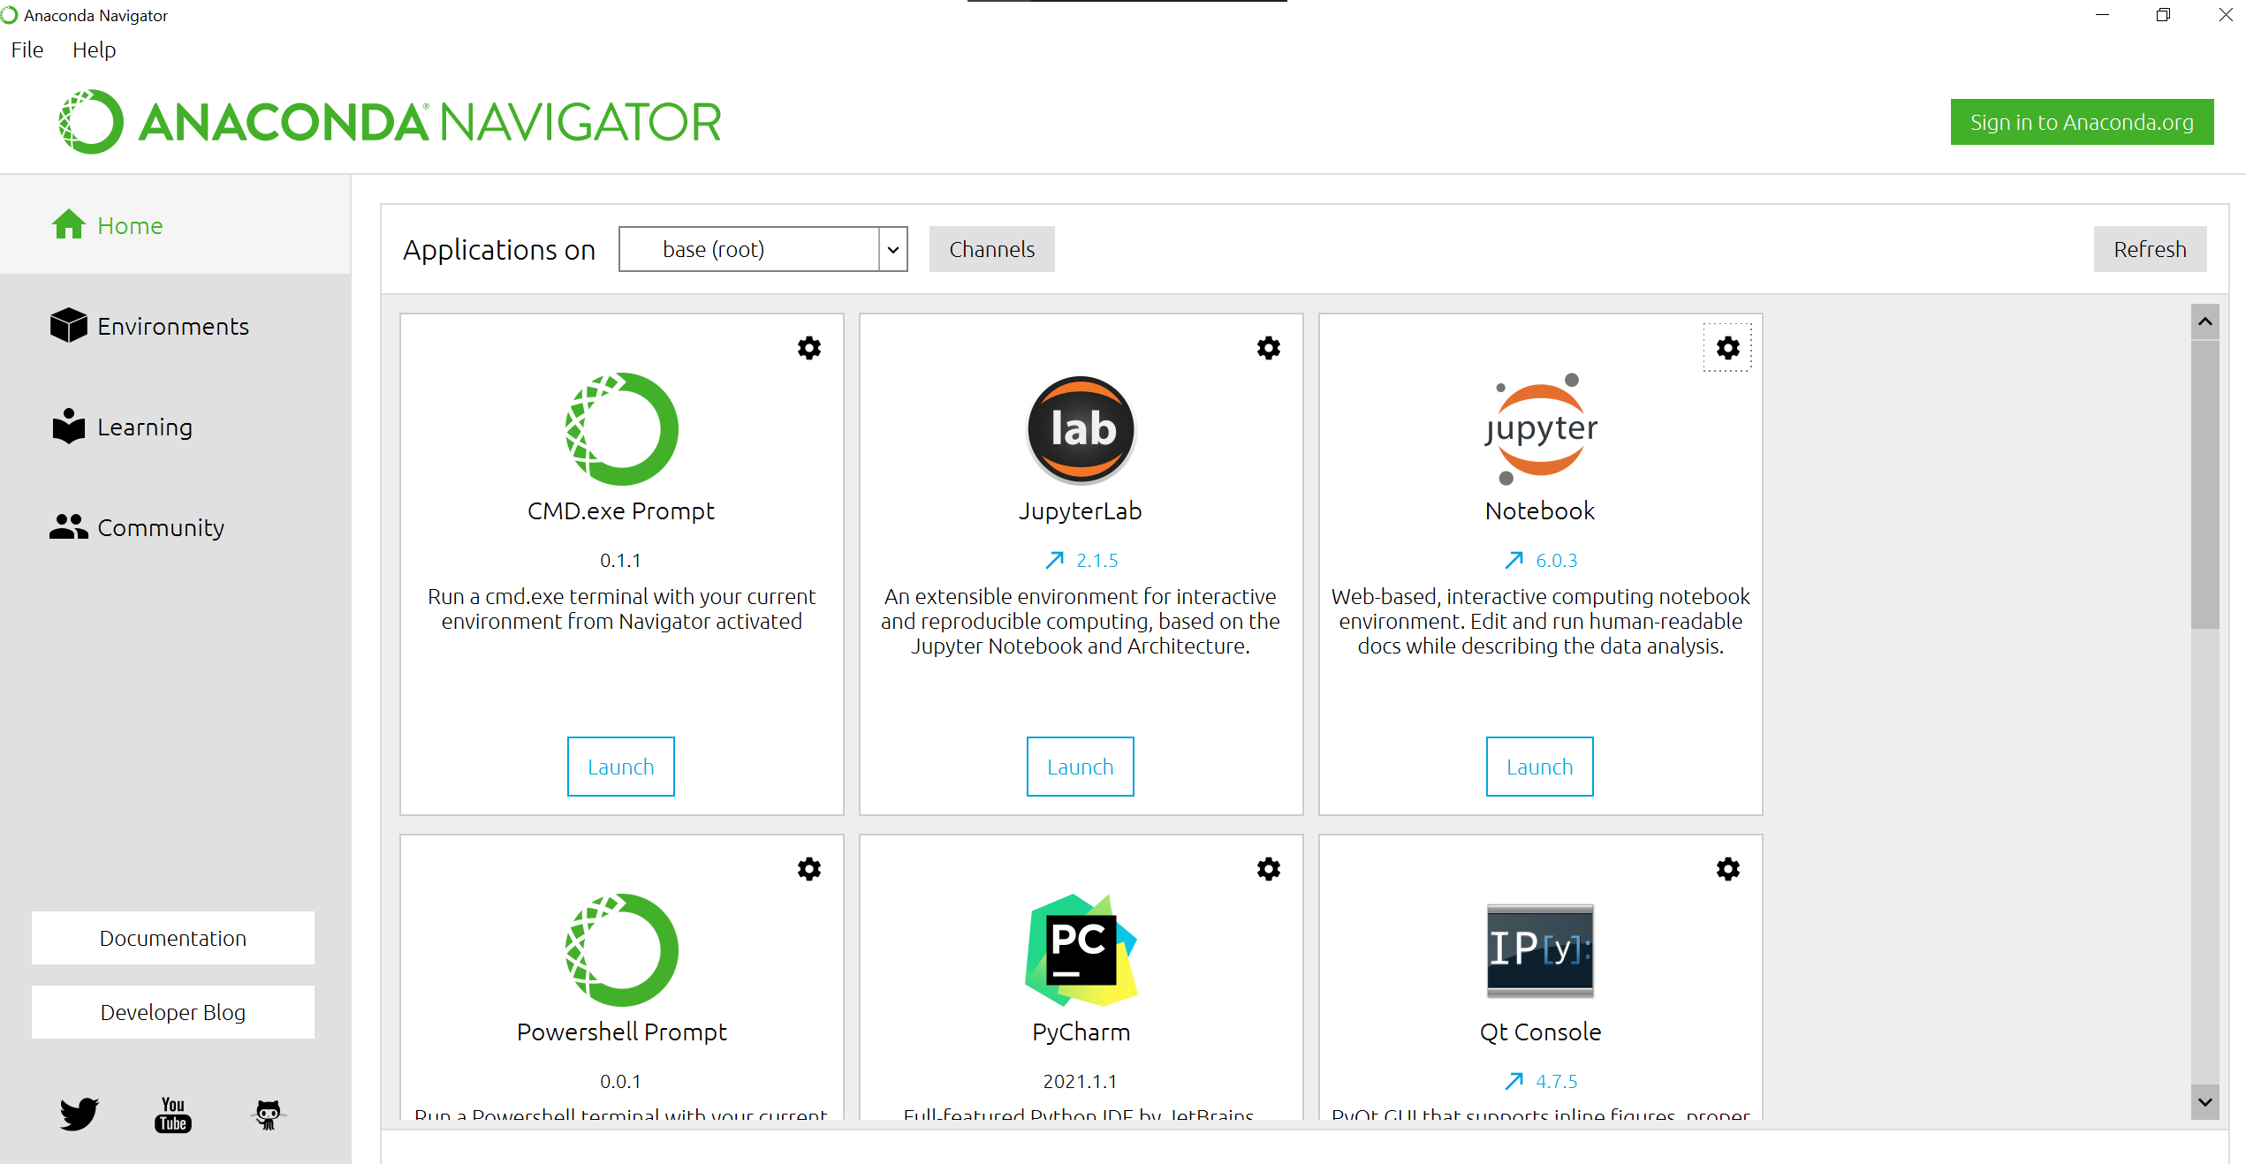

R:

Perquisites:

Install R: <https://www.r-project.org/>

Install R-Studio (optional, but very helpful): <https://www.rstudio.com/>

Libraries:

Make sure you have installed the following libraries



Authentication:

Make sure you enter the KEYS.

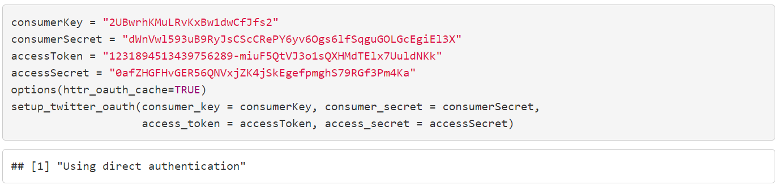

Searching for tweets and saving the results to a .csv file:

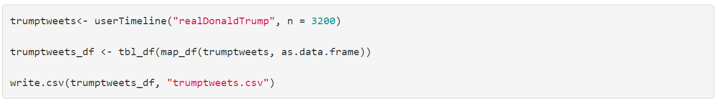

Read results from .csv



Python:

The software and frameworks used for twitter scraping in Python includes setting up a python virtual environment in ANACONDA

ANACONDA download: <https://www.anaconda.com/products/individual>

After installation the ANACONDA Navigator will open up.

Launch the Jupyter Notebook

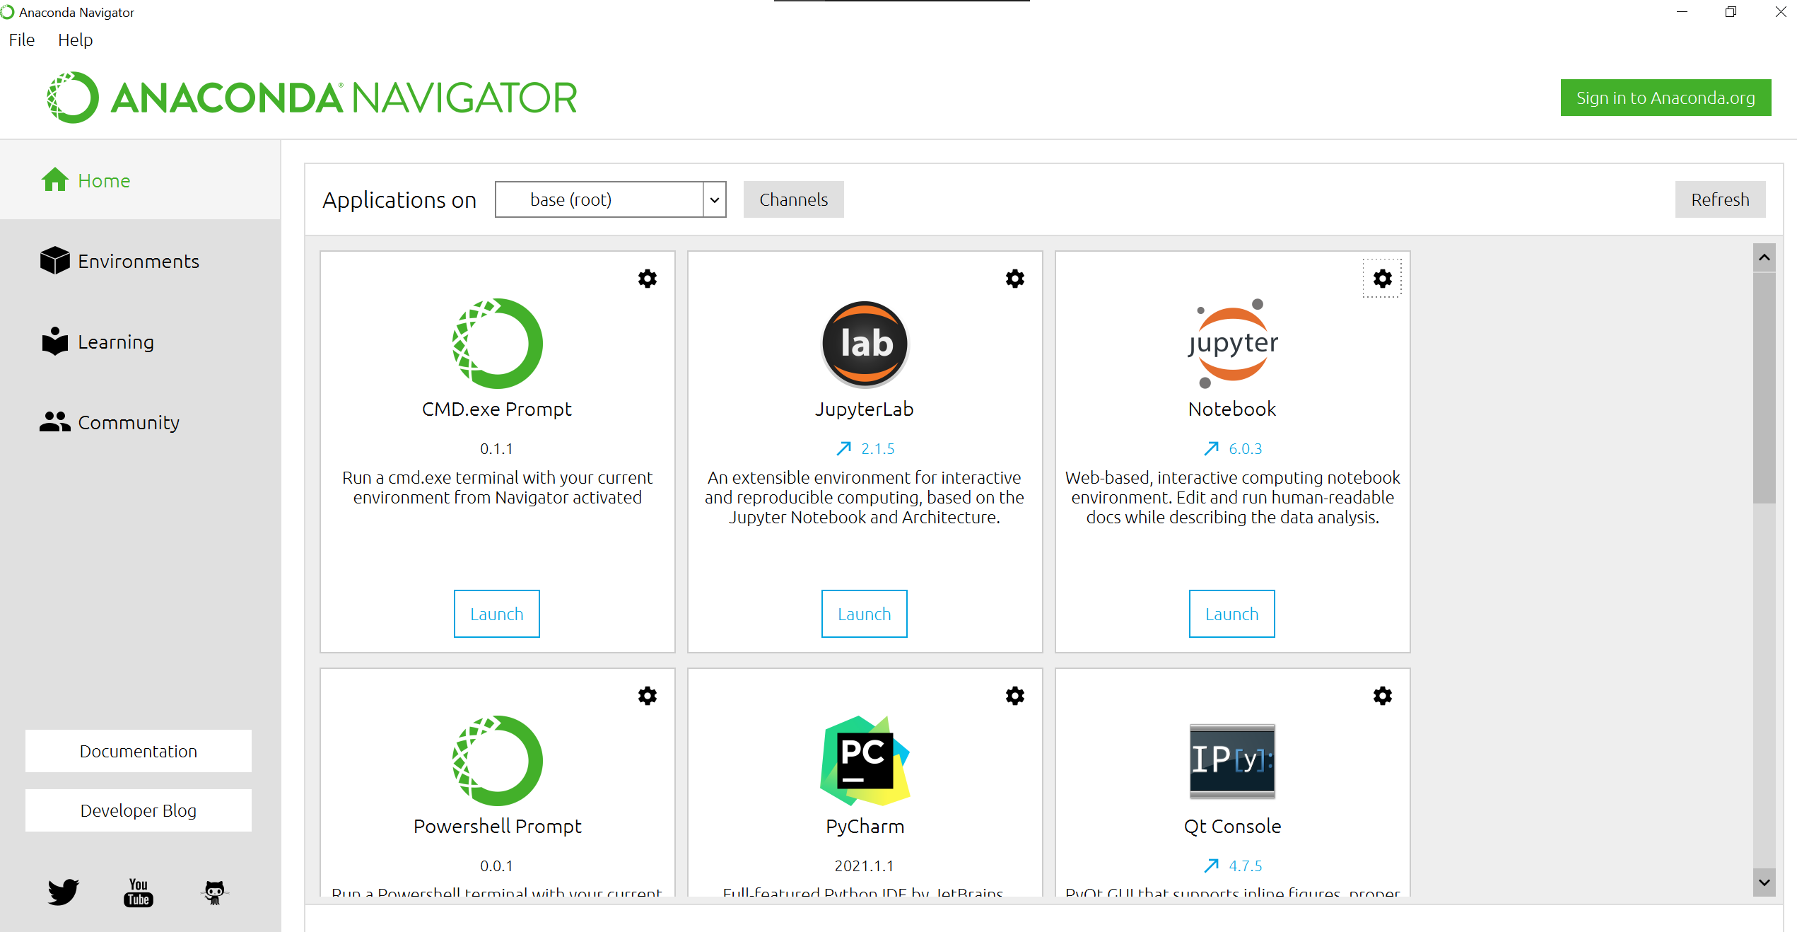

Create new and empty Jupyter Notebook:

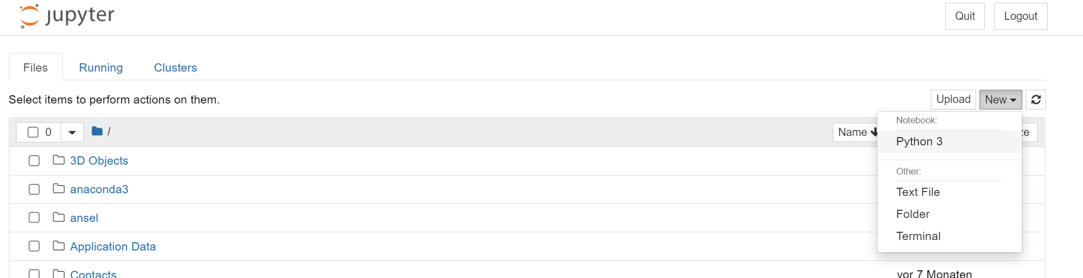

After the file has been created follow the steps from the python .ipynb files from the course.